Individual log – WEEK 3
Individual log item | Your answer
Name | HADSHEN THAVASEELAN
Student ID | 16247806
GitHub username | Hads44
What I worked on today | Organized the meeting with minutes  Report writing of WEEK 3 Task, combining Project development, Appendices, Presentation and Individual portfolio
Tool I used | HTML, JS & CSS
File/prototype part I created or edited | Report Writing  Appendix planning
Commit message or evidence | 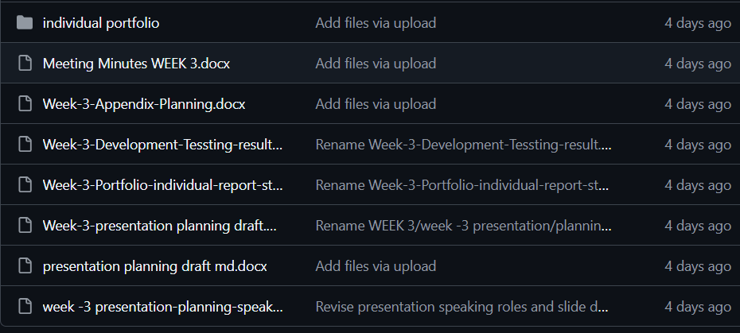  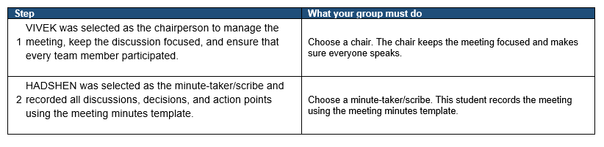  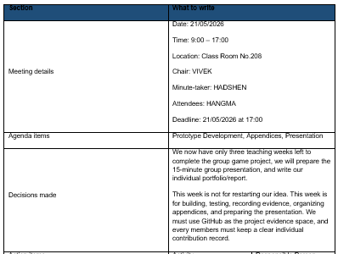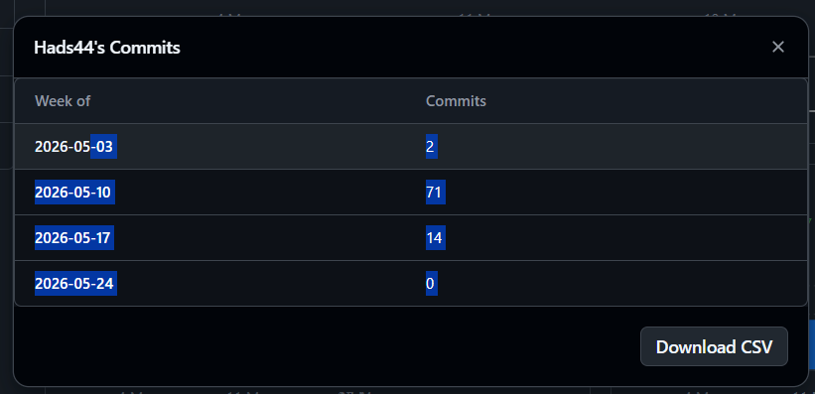
What I learned | I learned how to organize and document meeting minutes effectively while improving my report writing and project documentation skills.  I also improved my understanding of structuring appendices, presentations, and individual portfolio content using HTML, CSS, and JavaScript concepts.
What I need to do next | I need to continue improving the project report by refining the formatting, content structure, and presentation details.  I should also focus on completing the remaining portfolio updates and reviewing the project development progress before the next submission.

